1. **INTRODUCTION**
   1. *overview*
      * *Description of the project*

Project Description:

UrbanAura Interiors , a Interior Designing company uses Zoho books to effectively manage their financial processes, maintain accurate records, and make informed financial decisions. This integration enhances their overall business efficiency and contributes to their success in the interior design industry.

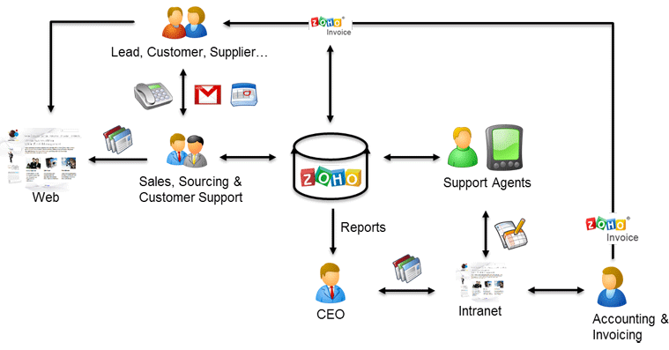

1. **Problem definition & design Thinking**
   1. *Empathy map*

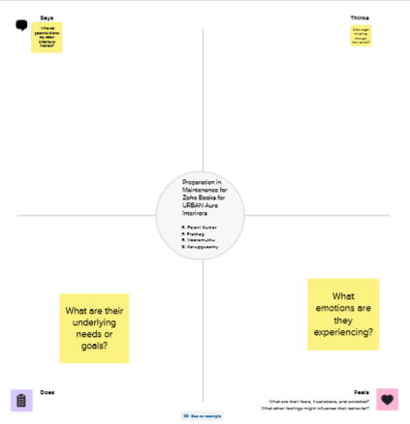

* 1. *Ideation & Brainstorming map*

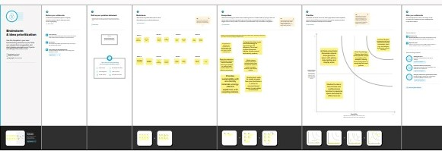

1. **Result Profit&loss**

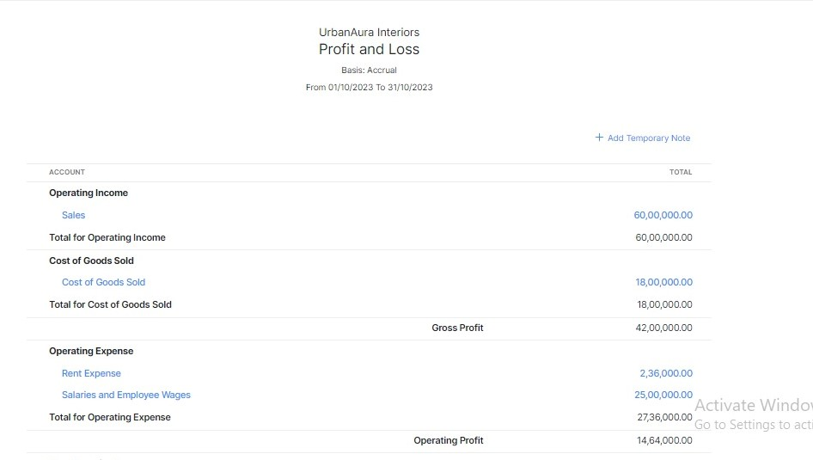

Balance sheet:

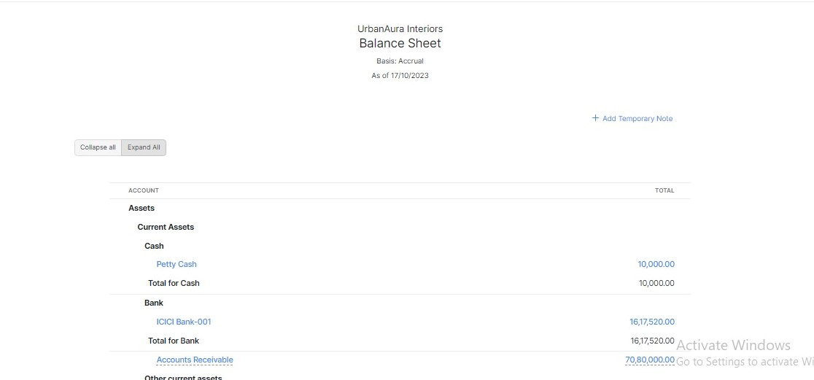

Purchase order:

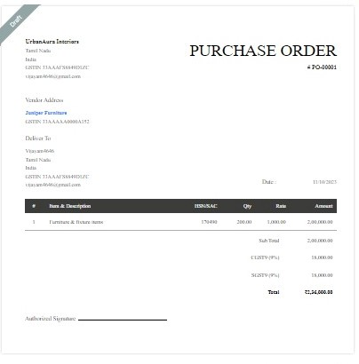

**SALES ORDER:**

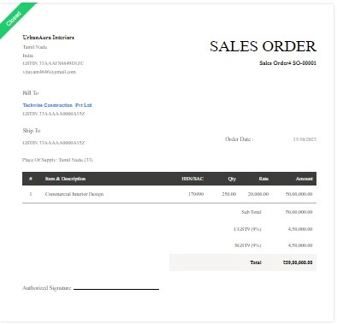

**INVOICE:**

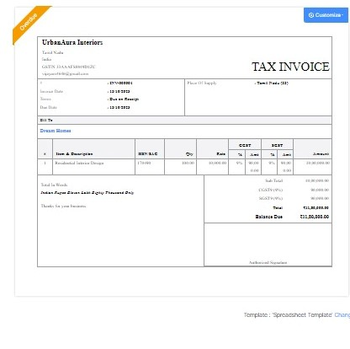

**BILLS:**

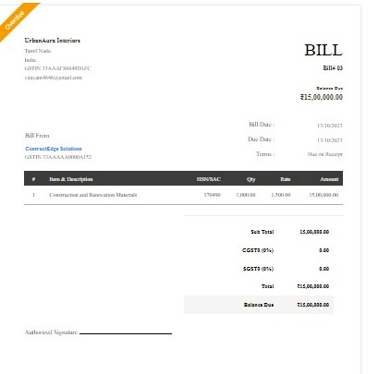

ADVANTAGES OF URBANAURA INTERIORS:

**Urban style is a mix of different styles, with the main characteristics being freedom and individuality. This design style is not just about the look but its philosophy.**

DISADVANTAGES OF URBANAURA INTERIORS:

**Interior design can be a great way to express your own personal style, and it can make your home more comfortable and inviting. It can also be a great way to add value to your home, if you plan to sell it in the future.**

1. *APPLICATIONS:*

***URBANAURA INTERIORS***

1. **Conclusion:**

**Urban interiors borrow from the raw elements of industrial settings like exposed metal frameworks and brick facades**

1. **FUTURE SCOPE:**

The future of interior design is****a blend of clean lines mixed with warmer, more welcoming textures and patterns****

1. **APPENDIX:**

[**https://github.com/URBANAURAMEMBERS001/URBAN-AURO-INTERIOR-_NM2023TMID23178**](https://github.com/URBANAURAMEMBERS001/URBAN-AURO-INTERIOR-_NM2023TMID23178)

|  |
| --- |
| <!DOCTYPE html> |
|  | <html lang="en" data-color-mode="auto" data-light-theme="light" data-dark-theme="dark" data-a11y-animated-images="system" data-a11y-link-underlines="true"> |
|  |  |
|  | <style> |
|  | /* for each iteration, uncomment the CSS variable */ |
|  |  |
|  | /* light themes */ |
|  | [data-color-mode="light"][data-light-theme*="light"], |
|  | [data-color-mode="auto"][data-light-theme*="light"] { |
|  | /* iteration 1 */ |
|  | --border-color-iteration-1: #C8CCD0; |
|  | /* iteration 2 */ |
|  | --border-color-iteration-2: #BABFC5; |
|  | /* iteration 3 */ |
|  | --border-color-iteration-3: #A6ADB4; |
|  | /* iteration final */ |
|  | --border-color-iteration-4: #868F99; |
|  |  |
|  | /* the first value is the final step, which falls back to previous iterations */ |
|  | --control-borderColor-rest: var(--border-color-iteration-4, var(--border-color-iteration-3, var(--border-color-iteration-2, var(--border-color-iteration-1)))) !important; |
|  | } |
|  |  |
|  | /* dark themes */ |
|  | [data-color-mode="dark"][data-dark-theme*="dark"], |
|  | [data-color-mode="auto"][data-light-theme*="dark"] { |
|  | /* iteration 1 */ |
|  | --border-color-iteration-1: #363940; |
|  | /* iteration 2 */ |
|  | --border-color-iteration-2: #3F434B; |
|  | /* iteration 3 */ |
|  | --border-color-iteration-3: #4B5159; |
|  | /* iteration final */ |
|  | --border-color-iteration-4: #666E79; |
|  |  |
|  | /* the first value is the final step, which falls back to previous iterations */ |
|  | --control-borderColor-rest: var(--border-color-iteration-4, var(--border-color-iteration-3, var(--border-color-iteration-2, var(--border-color-iteration-1)))) !important; |
|  | } |
|  |  |
|  | [data-color-mode="dark"][data-dark-theme="dark_dimmed"], |
|  | [data-color-mode="dark"][data-dark-theme="light_high_contrast"], |
|  | [data-color-mode="dark"][data-dark-theme="dark_high_contrast"], |
|  | [data-color-mode="light"][data-light-theme="dark_dimmed"], |
|  | [data-color-mode="light"][data-light-theme="light_high_contrast"], |
|  | [data-color-mode="light"][data-light-theme="dark_high_contrast"] { |
|  | /* skip these themes, use the fallback */ |
|  | --control-borderColor-rest: initial !important; |
|  | } |
|  |  |
|  | @media (prefers-color-scheme: dark) { |
|  | /* dark colors in dark mode */ |
|  | [data-color-mode="auto"][data-dark-theme*="dark"] { |
|  | /* iteration 1 */ |
|  | --border-color-iteration-1: #363940; |
|  | /* iteration 2 */ |
|  | --border-color-iteration-2: #3F434B; |
|  | /* iteration 3 */ |
|  | --border-color-iteration-3: #4B5159; |
|  | /* iteration final */ |
|  | --border-color-iteration-4: #666E79; |
|  |  |
|  | /* the first value is the final step, which falls back to previous iterations */ |
|  | --control-borderColor-rest: var(--border-color-iteration-4, var(--border-color-iteration-3, var(--border-color-iteration-2, var(--border-color-iteration-1)))) !important; |
|  | } |
|  |  |
|  | /* light colors in dark mode */ |
|  | [data-color-mode="auto"][data-dark-theme*="light"] { |
|  | /* iteration 1 */ |
|  | --border-color-iteration-1: #C8CCD0; |
|  | /* iteration 2 */ |
|  | --border-color-iteration-2: #BABFC5; |
|  | /* iteration 3 */ |
|  | --border-color-iteration-3: #A6ADB4; |
|  | /* iteration final */ |
|  | --border-color-iteration-4: #868F99; |
|  |  |
|  | /* the first value is the final step, which falls back to previous iterations */ |
|  | --control-borderColor-rest: var(--border-color-iteration-4, var(--border-color-iteration-3, var(--border-color-iteration-2, var(--border-color-iteration-1)))) !important; |
|  | } |
|  |  |
|  | [data-color-mode="auto"][data-dark-theme="dark_dimmed"], |
|  | [data-color-mode="auto"][data-dark-theme="light_high_contrast"], |
|  | [data-color-mode="auto"][data-dark-theme="dark_high_contrast"] { |
|  | /* skip these themes, use the fallback */ |
|  | --control-borderColor-rest: initial !important; |
|  | } |
|  | } |
|  |  |
|  | @media (prefers-color-scheme: light) { |
|  | /* dark colors in light mode */ |
|  | [data-color-mode="auto"][data-light-theme*="dark"] { |
|  | /* iteration 1 */ |
|  | --border-color-iteration-1: #363940; |
|  | /* iteration 2 */ |
|  | --border-color-iteration-2: #3F434B; |
|  | /* iteration 3 */ |
|  | --border-color-iteration-3: #4B5159; |
|  | /* iteration final */ |
|  | --border-color-iteration-4: #666E79; |
|  |  |
|  | /* the first value is the final step, which falls back to previous iterations */ |
|  | --control-borderColor-rest: var(--border-color-iteration-4, var(--border-color-iteration-3, var(--border-color-iteration-2, var(--border-color-iteration-1)))) !important; |
|  | } |
|  |  |
|  | /* light colors in light mode */ |
|  | [data-color-mode="auto"][data-light-theme*="light"] { |
|  | /* iteration 1 */ |
|  | --border-color-iteration-1: #C8CCD0; |
|  | /* iteration 2 */ |
|  | --border-color-iteration-2: #BABFC5; |
|  | /* iteration 3 */ |
|  | --border-color-iteration-3: #A6ADB4; |
|  | /* iteration final */ |
|  | --border-color-iteration-4: #868F99; |
|  |  |
|  | /* the first value is the final step, which falls back to previous iterations */ |
|  | --control-borderColor-rest: var(--border-color-iteration-4, var(--border-color-iteration-3, var(--border-color-iteration-2, var(--border-color-iteration-1)))) !important; |
|  | } |
|  |  |
|  | [data-color-mode="auto"][data-light-theme="dark_dimmed"], |
|  | [data-color-mode="auto"][data-light-theme="light_high_contrast"], |
|  | [data-color-mode="auto"][data-light-theme="dark_high_contrast"] { |
|  | /* skip these themes, use the fallback */ |
|  | --control-borderColor-rest: initial !important; |
|  | } |
|  | } |
|  | </style> |

rel=”stylesheet” href=”./NM2023TMID22539_profit_and_loss.pdf at main · asmku643mku643c1c31260_NM2023TMID22539 · GitHub_files/light-b92e9647318f.css”><link crossorigin=”anonymous” media=”all” rel=”stylesheet” href=”./NM2023TMID22539_profit_and_loss.pdf at main · asmku643mku643c1c31260_NM2023TMID22539 · GitHub_files/dark-5d486a4ede8e.css”><link data-color-theme=”dark_dimmed” crossorigin=”anonymous” media=”all” rel=”stylesheet” data-href=https://github.githubassets.com/assets/dark_dimmed-27c8d635e4e5.css><link data-color-theme=”dark_high_contrast” crossorigin=”anonymous” media=”all”

rel=”stylesheet”

data-href=https://github.githubassets.com/assets/dark_high_contrast-8438e75afd36.css><lin k data-color-theme=”dark_colorblind” crossorigin=”anonymous” media=”all” rel=”stylesheet” data-href=https://github.githubassets.com/assets/dark_colorblind-bf5665b96628.css><link data-color-theme=”light_colorblind” crossorigin=”anonymous” media=”all” rel=”stylesheet” data-href=https://github.githubassets.com/assets/light_colorblind-c414b5ba1dce.css><link data-color-theme=”light_high_contrast” crossorigin=”anonymous” media=”all” rel=”stylesheet”

data-href=https://github.githubassets.com/assets/light_high_contrast-e5868b7374db.css><lin k data-color-theme=”light_tritanopia” crossorigin=”anonymous” media=”all” rel=”stylesheet” data-href=https://github.githubassets.com/assets/light_tritanopia-299ac9c64ec0.css><link data-color-theme=”dark_tritanopia” crossorigin=”anonymous” media=”all” rel=”stylesheet” data-href=h[ttps://github.githubassets.com/assets/dark_tritanopia-3a26e78ad0ff.css>](https://github.githubassets.com/assets/light_high_contrast-e5868b7374db.css)

<link cros[sorigin=”anonymous” media=”all” rel=”stylesheet”](https://github.githubassets.com/assets/dark_tritanopia-3a26e78ad0ff.css) href=”./NM2023TMID22539_profit_and_loss.pdf at main · asmku643mku643c1c31260_NM2023TMID22539 · GitHub_files/primer-primitives-6143c8f97ed1.css”>

<link crossorigin=”anonymous” media=”all” rel=”stylesheet” href=”./NM2023TMID22539_profit_and_loss.pdf at main · asmku643mku643c1c31260_NM2023TMID22539 · GitHub_files/primer-d6dcdf72e61d.css”>

<link crossorigin=”anonymous” media=”all” rel=”stylesheet” href=”./NM2023TMID22539_profit_and_loss.pdf at main · asmku643mku643c1c31260_NM2023TMID22539 · GitHub_files/global-ab1c3e3e5644.css”>

<link crossorigin=”anonymous” media=”all” rel=”stylesheet” href=”./NM2023TMID22539_profit_and_loss.pdf at main · asmku643mku643c1c31260_NM2023TMID22539 · GitHub_files/github-757ef6ea9a38.css”>

<link crossorigin=”anonymous” media=”all” rel=”stylesheet” href=”./NM2023TMID22539_profit_and_loss.pdf at main · asmku643mku643c1c31260_NM2023TMID22539 · GitHub_files/code-71ecd5638fbf.css”>

<script type=”application/json”

id=”client-env”>{“locale”:”en”,”featureFlags”:[“failbot_handle_non_errors”,”geojson_azure_m aps”,”image_metric_tracking”,”turbo_experiment_risky”,”sample_network_conn_type”]}</scri pt>

<script crossorigin=”anonymous” defer=”defer” type=”application/javascript” src=”./NM2023TMID22539_profit_and_loss.pdf at main · asmku643mku643c1c31260_NM2023TMID22539 ·

GitHub_files/wp-runtime-86f14561f3b0.js.download”></script>

<script crossorigin=”anonymous” defer=”defer” type=”application/javascript” src=”./NM2023TMID22539_profit_and_loss.pdf at main · asmku643mku643c1c31260_NM2023TMID22539 ·

GitHub_files/vendors-node_modules_dompurify_dist_purify_js-64d590970fa6.js.download”>

</script>

<script crossorigin=”anonymous” defer=”defer” type=”application/javascript” src=”./NM2023TMID22539_profit_and_loss.pdf at main · asmku643mku643c1c31260_NM2023TMID22539 ·

GitHub_files/vendors-node_modules_stacktrace-parser_dist_stack-trace-parser_esm_js-node_ modules_github_bro-a4c183-18bf85b8e9f4.js.download”></script>

<script crossorigin=”anonymous” defer=”defer” type=”application/javascript” src=”./NM2023TMID22539_profit_and_loss.pdf at main · asmku643mku643c1c31260_NM2023TMID22539 ·

GitHub_files/ui_packages_soft-nav_soft-nav_ts-56133143b228.js.download”></script>

<script crossorigin=”anonymous” defer=”defer” type=”application/javascript” src=”./NM2023TMID22539_profit_and_loss.pdf at main · asmku643mku643c1c31260_NM2023TMID22539 ·

GitHub_files/environment-fc6543d75794.js.download”></script>

<script crossorigin=”anonymous” defer=”defer” type=”application/javascript” src=”./NM2023TMID22539_profit_and_loss.pdf at main · asmku643mku643c1c31260_NM2023TMID22539 ·

GitHub_files/vendors-node_modules_github_selector-observer_dist_index_esm_js-2646a2c53 3e3.js.download”></script>

<script crossorigin=”anonymous” defer=”defer” type=”application/javascript” src=”./NM2023TMID22539_profit_and_loss.pdf at main · asmku643mku643c1c31260_NM2023TMID22539 ·

GitHub_files/vendors-node_modules_primer_behaviors_dist_esm_focus-zone_js-d55308df50 23.js.download”></script>

<script crossorigin=”anonymous” defer=”defer” type=”application/javascript” src=”./NM2023TMID22539_profit_and_loss.pdf at main · asmku643mku643c1c31260_NM2023TMID22539 ·

GitHub_files/vendors-node_modules_github_relative-time-element_dist_index_js-99e288659 d4f.js.download”></script>

<script crossorigin=”anonymous” defer=”defer” type=”application/javascript” src=”./NM2023TMID22539_profit_and_loss.pdf at main · asmku643mku643c1c31260_NM2023TMID22539 ·

GitHub_files/vendors-node_modules_fzy_js_index_js-node_modules_github_combobox-nav_ dist_index_js-node_modu-344bff-91b70bb50d68.js.download”></script>

<script crossorigin=”anonymous” defer=”defer” type=”application/javascript” src=”./NM2023TMID22539_profit_and_loss.pdf at main · asmku643mku643c1c31260_NM2023TMID22539 ·

GitHub_files/vendors-node_modules_delegated-events_dist_index_js-node_modules_github_ auto-complete-element-81d69b-f766607dc0c8.js.download”></script>

<script crossorigin=”anonymous” defer=”defer” type=”application/javascript” src=”./NM2023TMID22539_profit_and_loss.pdf at main · asmku643mku643c1c31260_NM2023TMID22539 ·

GitHub_files/vendors-node_modules_github_filter-input-element_dist_index_js-node_module s_github_remote-inp-2e8678-d593bf262480.js.download”></script>

<script crossorigin=”anonymous” defer=”defer” type=”application/javascript” src=”./NM2023TMID22539_profit_and_loss.pdf at main · asmku643mku643c1c31260_NM2023TMID22539 ·

GitHub_files/vendors-node_modules_github_file-attachment-element_dist_index_js-node_m odules_primer_view-co-70ad06-9f8bb7e4a8fa.js.download”></script>

<script crossorigin=”anonymous” defer=”defer” type=”application/javascript” src=”./NM2023TMID22539_profit_and_loss.pdf at main · asmku643mku643c1c31260_NM2023TMID22539 ·

GitHub_files/github-elements-30961cfd137b.js.download”></script>

<script crossorigin=”anonymous” defer=”defer” type=”application/javascript” src=”./NM2023TMID22539_profit_and_loss.pdf at main · asmku643mku643c1c31260_NM2023TMID22539 ·

GitHub_files/element-registry-e5f51987a7c5.js.download”></script>

<script crossorigin=”anonymous” defer=”defer” type=”application/javascript” src=”./NM2023TMID22539_profit_and_loss.pdf at main · asmku643mku643c1c31260_NM2023TMID22539 ·

GitHub_files/vendors-node_modules_lit-html_lit-html_js-4ccebb6ebf7d.js.download”></script

>

<script crossorigin=”anonymous” defer=”defer” type=”application/javascript” src=”./NM2023TMID22539_profit_and_loss.pdf at main · asmku643mku643c1c31260_NM2023TMID22539 ·

GitHub_files/vendors-node_modules_github_mini-throttle_dist_index_js-node_modules_gith ub_alive-client_dist-bf5aa2-504c8d53fb8e.js.download”></script>

<script crossorigin=”anonymous” defer=”defer” type=”application/javascript” src=”./NM2023TMID22539_profit_and_loss.pdf at main · asmku643mku643c1c31260_NM2023TMID22539 ·

GitHub_files/vendors-node_modules_morphdom_dist_morphdom-esm_js-b1fdd7158cf0.js.do wnload”></script>

<script crossorigin=”anonymous” defer=”defer” type=”application/javascript” src=”./NM2023TMID22539_profit_and_loss.pdf at main · asmku643mku643c1c31260_NM2023TMID22539 ·

GitHub_files/vendors-node_modules_github_turbo_dist_turbo_es2017-esm_js-9a3541181451

.js.download”></script>

<script crossorigin=”anonymous” defer=”defer” type=”application/javascript” src=”./NM2023TMID22539_profit_and_loss.pdf at main · asmku643mku643c1c31260_NM2023TMID22539 ·

GitHub_files/vendors-node_modules_github_remote-form_dist_index_js-node_modules_scrol l-anchoring_dist_scro-52dc4b-e1e33bfc0b7e.js.download”></script>

<script crossorigin=”anonymous” defer=”defer” type=”application/javascript” src=”./NM2023TMID22539_profit_and_loss.pdf at main · asmku643mku643c1c31260_NM2023TMID22539 ·

GitHub_files/vendors-node_modules_color-convert_index_js-35b3ae68c408.js.download”></s cript>

<script crossorigin=”anonymous” defer=”defer” type=”application/javascript” src=”./NM2023TMID22539_profit_and_loss.pdf at main · asmku643mku643c1c31260_NM2023TMID22539 ·

GitHub_files/vendors-node_modules_primer_behaviors_dist_esm_dimensions_js-node_modu les_github_jtml_lib_index_js-a18147cea3a6.js.download”></script>

<script crossorigin=”anonymous” defer=”defer” type=”application/javascript” src=”./NM2023TMID22539_profit_and_loss.pdf at main ·

asmku643mku643c1c31260_NM2023TMID22539 ·

GitHub_files/vendors-node_modules_github_paste-markdown_dist_index_esm_js-node_mod ules_github_quote-select-581a1f-4a3074d34892.js.download”></script>

<script crossorigin=”anonymous” defer=”defer” type=”application/javascript” src=”./NM2023TMID22539_profit_and_loss.pdf at main · asmku643mku643c1c31260_NM2023TMID22539 · GitHub_files/app_assets_modules_github_details-dialog_ts-app_assets_modules_github_fetc h_ts-add1ab03ecb3.js.download”></script>

<script crossorigin=”anonymous” defer=”defer” type=”application/javascript” src=”./NM2023TMID22539_profit_and_loss.pdf at main · asmku643mku643c1c31260_NM2023TMID22539 · GitHub_files/app_assets_modules_github_updatable-content_ts-ui_packages_hydro-analytics

_hydro-analytics_ts-0a5a30c9b976.js.download”></script>

<script crossorigin=”anonymous” defer=”defer” type=”application/javascript” src=”./NM2023TMID22539_profit_and_loss.pdf at main · asmku643mku643c1c31260_NM2023TMID22539 · GitHub_files/app_assets_modules_github_onfocus_ts-app_assets_modules_github_sticky-scr oll-into-view_ts-c56a5dfc8975.js.download”></script>

<script crossorigin=”anonymous” defer=”defer” type=”application/javascript” src=”./NM2023TMID22539_profit_and_loss.pdf at main · asmku643mku643c1c31260_NM2023TMID22539 · GitHub_files/app_assets_modules_github_behaviors_task-list_ts-app_assets_modules_github

_sso_ts-ui_packages-7d50ad-9491f2be61ee.js.download”></script>

<script crossorigin=”anonymous” defer=”defer” type=”application/javascript” src=”./NM2023TMID22539_profit_and_loss.pdf at main · asmku643mku643c1c31260_NM2023TMID22539 · GitHub_files/app_assets_modules_github_behaviors_ajax-error_ts-app_assets_modules_gith ub_behaviors_include-2e2258-d77f85c54572.js.download”></script>

<script crossorigin=”anonymous” defer=”defer” type=”application/javascript” src=”./NM2023TMID22539_profit_and_loss.pdf at main · asmku643mku643c1c31260_NM2023TMID22539 · GitHub_files/app_assets_modules_github_behaviors_commenting_edit_ts-app_assets_modul es_github_behaviors_ht-83c235-f22ac6b94445.js.download”></script>

<script crossorigin=”anonymous” defer=”defer” type=”application/javascript” src=”./NM2023TMID22539_profit_and_loss.pdf at main · asmku643mku643c1c31260_NM2023TMID22539 ·

GitHub_files/behaviors-8e3546d05c82.js.download”></script>

<script crossorigin=”anonymous” defer=”defer” type=”application/javascript” src=”./NM2023TMID22539_profit_and_loss.pdf at main · asmku643mku643c1c31260_NM2023TMID22539 ·

GitHub_files/vendors-node_modules_delegated-events_dist_index_js-node_modules_github_ catalyst_lib_index_js-623425af41e1.js.download”></script>

<script crossorigin=”anonymous” defer=”defer” type=”application/javascript” src=”./NM2023TMID22539_profit_and_loss.pdf at main · asmku643mku643c1c31260_NM2023TMID22539 ·

GitHub_files/notifications-global-0104a8043aa4.js.download”></script>

<script crossorigin=”anonymous” defer=”defer” type=”application/javascript” src=”./NM2023TMID22539_profit_and_loss.pdf at main · asmku643mku643c1c31260_NM2023TMID22539 ·

GitHub_files/vendors-node_modules_optimizely_optimizely-sdk_dist_optimizely_browser_es

_min_js-node_modules-089adc-8794271c9a65.js.download”></script>

<script crossorigin=”anonymous” defer=”defer” type=”application/javascript” src=”./NM2023TMID22539_profit_and_loss.pdf at main · asmku643mku643c1c31260_NM2023TMID22539 ·

GitHub_files/optimizely-b8ae60018b11.js.download”></script>

<script crossorigin=”anonymous” defer=”defer” type=”application/javascript” src=”./NM2023TMID22539_profit_and_loss.pdf at main · asmku643mku643c1c31260_NM2023TMID22539 ·

GitHub_files/vendors-node_modules_virtualized-list_es_index_js-node_modules_github_tem plate-parts_lib_index_js-677582870bfd.js.download”></script>

<script crossorigin=”anonymous” defer=”defer” type=”application/javascript” src=”./NM2023TMID22539_profit_and_loss.pdf at main · asmku643mku643c1c31260_NM2023TMID22539 ·

GitHub_files/vendors-node_modules_github_remote-form_dist_index_js-node_modules_dele gated-events_dist_inde-c537341-13ba07af3b2c.js.download”></script>

<script crossorigin=”anonymous” defer=”defer” type=”application/javascript” src=”./NM2023TMID22539_profit_and_loss.pdf at main · asmku643mku643c1c31260_NM2023TMID22539 · GitHub_files/app_assets_modules_github_ref-selector_ts-cad36de2ca60.js.download”></scrip t>

<script crossorigin=”anonymous” defer=”defer” type=”application/javascript” src=”./NM2023TMID22539_profit_and_loss.pdf at main ·

asmku643mku643c1c31260_NM2023TMID22539 · GitHub_files/codespaces-d5d24842ceda.js.download”></script>

<script crossorigin=”anonymous” defer=”defer” type=”application/javascript” src=”./NM2023TMID22539_profit_and_loss.pdf at main · asmku643mku643c1c31260_NM2023TMID22539 ·

GitHub_files/vendors-node_modules_github_filter-input-element_dist_index_js-node_module s_github_mini-throt-08ab15-d50c69097a3e.js.download”></script>

<script crossorigin=”anonymous” defer=”defer” type=”application/javascript” src=”./NM2023TMID22539_profit_and_loss.pdf at main · asmku643mku643c1c31260_NM2023TMID22539 ·

GitHub_files/vendors-node_modules_github_file-attachment-element_dist_index_js-node_m odules_github_mini-th-55cf52-b2acd5425c7c.js.download”></script>

<script crossorigin=”anonymous” defer=”defer” type=”application/javascript” src=”./NM2023TMID22539_profit_and_loss.pdf at main · asmku643mku643c1c31260_NM2023TMID22539 ·

GitHub_files/repositories-b80504a04cf8.js.download”></script>

<script crossorigin=”anonymous” defer=”defer” type=”application/javascript” src=”./NM2023TMID22539_profit_and_loss.pdf at main · asmku643mku643c1c31260_NM2023TMID22539 ·

GitHub_files/vendors-node_modules_github_remote-form_dist_index_js-node_modules_dele gated-events_dist_inde-0e9dbe-6435366f0862.js.download”></script>

<script crossorigin=”anonymous” defer=”defer” type=”application/javascript” src=”./NM2023TMID22539_profit_and_loss.pdf at main · asmku643mku643c1c31260_NM2023TMID22539 ·

GitHub_files/topic-suggestions-2e55863e3751.js.download”></script>

<script crossorigin=”anonymous” defer=”defer” type=”application/javascript” src=”./NM2023TMID22539_profit_and_loss.pdf at main · asmku643mku643c1c31260_NM2023TMID22539 ·

GitHub_files/code-menu-6bd50a0647d6.js.download”></script>

<meta http-equiv=”x-pjax-version” content=”d98aab6b69dc43e4407b1369c7bbfcf76dfab2d839011937153201c9b943f42f” data-turbo-track=”reload”>

<meta http-equiv=”x-pjax-csp-version” content=”ee14a7165914197d62e19f664bfb961fcfdfc1ec31939a5c7b137fbab1751c87” data-turbo-track=”reload”>

<meta http-equiv=”x-pjax-css-version” content=”664233c3fea08fdf2ac6994c09da8d00c5e5f750fe523a7605f44e0aafe71afe” data-turbo-track=”reload”>

<meta http-equiv=”x-pjax-js-version” content=”dd74378fedb3de5476a9fb9b72cce29ed416c09618bddd59f59777f848393889” data-turbo-track=”reload”>

<style type=”text/css” id=”operaUserStyle”></style>

<script type=”application/javascript” src=”./NM2023TMID22539_profit_and_loss.pdf at main

· asmku643mku643c1c31260_NM2023TMID22539 · GitHub_files/react-lib-210c4b5934c3.js.download”></script><script

type=”application/javascript” src=”./NM2023TMID22539_profit_and_loss.pdf at main · asmku643mku643c1c31260_NM2023TMID22539 ·

GitHub_files/vendors-node_modules_primer_octicons-react_dist_index_esm_js-node_module s_primer_react_lib-es-3db9ab-5f4faa9f1811.js.download”></script><script type=”application/javascript” src=”./NM2023TMID22539_profit_and_loss.pdf at main · asmku643mku643c1c31260_NM2023TMID22539 ·

GitHub_files/vendors-node_modules_primer_react_lib-esm_Box_Box_js-96a44addc402.js.do wnload”></script><script type=”application/javascript” src=”./NM2023TMID22539_profit_and_loss.pdf at main · asmku643mku643c1c31260_NM2023TMID22539 ·

GitHub_files/vendors-node_modules_primer_react_lib-esm_Button_Button_js-node_modules

_primer_react_lib-esm_-f6da63-1976b80d3486.js.download”></script><script type=”application/javascript” src=”./NM2023TMID22539_profit_and_loss.pdf at main · asmku643mku643c1c31260_NM2023TMID22539 ·

GitHub_files/vendors-node_modules_primer_react_lib-esm_Truncate_Truncate_js-node_mod

ules_primer_react_lib—5d1957-92534314547a.js.download”></script><script type=”application/javascript” src=”./NM2023TMID22539_profit_and_loss.pdf at main · asmku643mku643c1c31260_NM2023TMID22539 ·

GitHub_files/vendors-node_modules_primer_react_lib-esm_Button_index_js-node_modules_ primer_react_lib-esm_O-279bf8-c9a61955d545.js.download”></script><script type=”application/javascript” src=”./NM2023TMID22539_profit_and_loss.pdf at main · asmku643mku643c1c31260_NM2023TMID22539 ·

GitHub_files/vendors-node_modules_primer_react_lib-esm_Text_Text_js-node_modules_pri mer_react_lib-esm_Text-85a14b-0f28951279b7.js.download”></script><script type=”application/javascript” src=”./NM2023TMID22539_profit_and_loss.pdf at main · asmku643mku643c1c31260_NM2023TMID22539 ·

GitHub_files/vendors-node_modules_primer_react_lib-esm_ActionList_index_js-535c8ee1ebe 8.js.download”></script><script type=”application/javascript” src=”./NM2023TMID22539_profit_and_loss.pdf at main · asmku643mku643c1c31260_NM2023TMID22539 ·

GitHub_files/vendors-node_modules_primer_react_lib-esm_ActionMenu_ActionMenu_js-2f0 8ef908241.js.download”></script><script type=”application/javascript” src=”./NM2023TMID22539_profit_and_loss.pdf at main · asmku643mku643c1c31260_NM2023TMID22539 · GitHub_files/vendors-